Supplemental data
Generic Validation / Verification Form
This form is intended as a guide to aid laboratories in developing a suitable validation / verification procedure. A suggested methodology for using the form has been given below.
The terms ‘investigating scientist’ and ‘senior scientist’ have been used for illustration of an authorization procedure – organisation of authorization systems is a matter for individual laboratories.
- Section 1 should be completed as far as possible to establish the goals and general format of the validation / verification.
- Sections 1.1 “Intended use or application” and 1.2 “Requirements” must be completed at the start of the procedure. The assessment of the validation/verification depends formally on confirmation, through the provision of objective evidence, that these requirements have been fulfilled.
- If mentioned (1.2), the “Expected Performance” should be distinguished from the “Requirements”, which must be shown to have been fulfilled.
E.g. The statement “should detect all known point mutations of hemophilia A” could be included as a guide in the Expected performance; if stated as a requirement, however, it would need to be proved.
- Section 2 covers the validation of utility which should be carried out for all validations and verifications. In the majority of cases this section can be completed on objective evidence from developmental work, design procedures (e.g. SNP checking primers) or by the use of limitations or controls in the on-going test. Where this is not the case, work plans for relevant parameters should be prepared as in 3 below.
- Appropriate parameters for experimental investigation should be identified with the aid of the table appendix A – a checklist is also provided at the top of section 3. For each parameter required, the investigating scientist develops a work plan based on section 3 (these are referenced 3.1, 3.2 to 3.n) by completing copies of sections 3.n.1 (‘Aims’, ‘Samples’ and ‘Methodology’). It is suggested that these be maintained in a single document.
Note: several parameters may be tested in a single experiment, for example sensitivity and specificity.
- The work plan[s] should be agreed and authorized by the investigating and the senior scientist by signing and dating in the boxes provided.
- The experimental work is performed and analysed by the investigating scientist who should then complete the ‘experimental results’ and ‘interpretation’ sections 3.n.2.
- The ‘outcome and limitations’ should be agreed between the investigating and senior scientists by signing and dating in the boxes provided.
- Points 3 to 6 should be repeated for each parameter to be tested.
- If there is any non-compliance between the experimental results and the required performance specification detailed in section 1.2 the parameter in question should to be re-examined to determine if the methodology can be changed or new limitations introduced to rectify the non-compliance. Any further work should be recorded in a new section 3 work plan. Alternatively the implementation can be abandoned.
- Once all the parameters have been satisfactorily investigated the investigating and senior scientist can agree and sign off the final conclusions in section 4.
- Assuming the validation / verification has been completed satisfactorily an implementation plan can be drawn up. Appendix B provides a basis for an administrative checklist for the implementation.
- Validation / Verification Details
Test name | MYC dPCR amplification assay | Reference | CCND ref.

  - Test details
Intended use or application | Outline the intended results of the test and how they will be used including any interpretative considerations; linked to 1.2 Performance Requirements.  To develop and validate a droplet digital PCR (ddPCR) assay for the detection of MYC (C, L and N) amplification.
Locus / Gene / Marker | Specify analyte[s]  MYC C - Chromosome 8: 127,735,434-127,741,434  MYC L - Chromosome 1: 39,895,426-39,902,256  MYC N - Chromosome 2: 15,940,564-15,947,007
Reference Sequence | e.g. NCBI accession number
Outline methodology | Describe the technology and how it will be employed  Droplet digital PCR provides high-precision, absolute quantification of nucleic target sequences. ddPCR counts nucleic acid molecules encapsulated in discrete, volumetrically defined water-in-oil droplet partitions. This uses Bio-Rad’s QX200 ddPCR system with the AutoDG.  Bio-Rad’s ddPCR system combines water-oil emulsion droplet technology with microfluidics. The QX200 droplet generator partitions samples into 20,000 droplets. PCR amplification is carried out within each droplet using a thermal cycler. After PCR, droplets are streamed single file on a QX200 droplet reader, which counts the fluorescent positive and negative droplets to calculate DNA concentration.  Before droplet generation, ddPCR reactions are prepared in a similar manner as real-time PCR reactions that use Taqman hydrolysis probes labelled with FAM and VIC (or HEX), reporter fluorophores, or an intercalating dye such as EvaGreen.
SOP | Reference internal SOP  SMD161_MYC amplification ddPCR assay
References | List any relevant documentation both internal and external indicating the derivation of the test and including performance specifications, publications and any previous validations  http://www.bio-rad.com/en-uk/applications-technologies/droplet-digital-pcr-ddpcr-technology

1.2 Validation details
Overall Aims | State clearly the overall aim of the validation  The aim of this validation is to show that ddPCR can be used to detect amplification in three MYC genes by comparing the dPCR to NGS results.
Requirements | Define the levels of performance that must be attained (accuracy, precision and any other performance requirements such as robustness or maximum failure rate). Linked to 1.1 Intended Use or Application and  If the gene is clearly amplified by NGS, we require the dPCR result to replicate the findings. For amplification that may be borderline or uncertain by NGS, we don’t have any expectations regarding the dPCR result.  For germline DNA controls, we require no amplification to be detected by dPCR result.  Based on these results, we will set a threshold to call amplification or no amplification.
Validation / Verification | State whether the study is a validation or verification and the justification for this course of action.  Validation – this is a new assay to determine whether dPCR can be used to detect MYC amplification.
Type | State the type of test and if the validation is to be performed at implementation or on an ongoing basis.  Type C. Validation will be performed at implementation although there will be ongoing analysis to ensure that thresholds etc. are still relevant and accurate.
Scope / limitations | List any pre existing limitations (e.g. test to be performed on DNA extracted from EDTA peripheral blood samples only)  Test can be performed on any DNA, with no limitations
Turn around time | The required TAT  N/A. Test is yet to be used in the diagnostic / clinical trial setting.
Other considerations | List any other factors that may affect the utility of the test for the intended purpose. Expected performance can be mentioned here.

2. Validation of Utility
Test name | MYC dPCR amplification assay | Reference | Internal ref.

Applicability of measurements | Is what is being tested appropriate and sufficient to achieve the desired results?  dPCR results will show us if the genes are amplified or not, and is therefore sufficient to achieve the desired result. In this validation, we will test known amplified samples (by NGS) and germline DNA (expected to be non-amplified)
Selectivity | Detail any test specific selectivity issues together with limitations and/or control measures taken to ensure test utility. A validation work plan (section 3) should be drawn up for any specific potential selectivity issues that cannot be eliminated by limitation or control measure[s].  There will be no test specific selectivity issues.
Interferences | Detail any test specific interference factors together with limitations and/or control measures taken to ensure test utility. A validation work plan (section 3) should be drawn up for any specific potential interference that cannot be eliminated by limitation or control measure[s].  There will be no test specific interference factors.
Cross-reactivity | Detail any test specific cross-reactivity together with limitations and/or control measures taken to ensure test utility. A validation work plan (section 3) should be drawn up for any specific potential cross-reactivity that cannot be eliminated by limitation or control measure[s].  There will be no test specific cross-reactivity.

3.n Validation / Verification for [insert parameter]
A copy of this section should be filled in for all parameters to be tested.
Test name | MYC dPCR amplification assay | Reference | Internal ref.

 | Sensitivity |  | Trueness |  | Reproducibility |  | Limit of quantification
 | Specificity |  | Repeatability |  | Robustness |  | Linearity
X | Accuracy |  | Intermediate precision |  | Limit of detection |  | Measurement uncertainty

3.n.1 Work plan
Section aims | Describe the specific aims of this section of the validation  The aim is to determine whether using dPCR to determine MYC copy number changes is accurate when comparing to NGS results.
Samples | Describe the samples to be used including [where relevant] numbers and type[s] of mutations present, relevant physical characteristics and how the sample status has been derived (i.e. the reference or ‘gold standard’ test). It may be appropriate to reference another document or database here.  We selected all research samples with known amplification in one of the MYC genes (C, N, L) as determined by NGS. In total, there were 33 positive control samples. Of these, 27 had MYC-N amplification and 6 had MYC-C amplification. We did not have any samples with MYC-L amplification, and therefore this will be subject to ongoing validation.  In addition, we had 10 further samples that had suspected MYC-C gain by NGS.  For controls, we used 43 germline DNA samples which should not have any amplification in the MYC genes.
Methodology | Describe the method to be used to evaluate the specific parameter  Droplet digital PCR (dPCR) will be used. The technology has previously been validated for both somatic mutation detection and both HER2 and FGFR2 copy number analysis and are currently in use (SMD115 and SMD94, respectively).  MYC-specific methodology:  - Assays ordered from ThermoFisher:  EIF2C1, NAGK and RNase P are used as reference genes – it is not expected for the copy number of these genes to be altered, even in cancer samples.  - Two multiplex batches were made up using the following (for 1 reaction and scaled up) which were frozen ready for use:  - For dPCR, the following reaction mix was used per well:  N.B for experiments where individual MYC assays were tested, the MYC multiplex mix was replaced with 1 µl of the relevant MYC assay.  - PCR was performed using the following thermocycler conditions:  95°C: 10 min  94°C: 30 sec  40 cycles  56°C: 1 min  98°C: 10 min  4°C: Hold  Analysis  - Analysis is performed using the QuantaSoft Analysis Pro software. This allows each cluster of droplets to be identified.  - The ratio of the specific MYC gene versus reference genes is calculated automatically by the software and this data can be exported.  - The QC will be based on other dPCR protocols currently in use:  - Amplification will be called when MYC:reference gene ratio is >2.  - A total of > 300 reference gene droplets is required (~100 per reference gene) to ensure it is not under-loaded but not discriminating against samples with a lower yield. However, if amplification is detected where there are <300 reference gene droplets, then this will be a valid result and can be reported.
  TaqMan Assay ID | Gene | Chromosome | Amplicon length | Dye
  Hs00201049_cn | MYCN | 2 | 95 bp | FAM
  Hs02382177_cn | Myc C | 8 | 98 bp | FAM
  Hs00500549_cn | Myc L | 1 | 96bp | FAM
  Hs05793098_cn | EIF2C1 | 1 | 96bp | VIC
  Hs04579842_cn | NAGK | 2 | 94 bp | VIC
  Cat # 4403326 | RNase P | 14 | 87bp | VIC
   |  | 1X
  MYC multiplex | MYC N | 0.25 µl
  MYC multiplex | Myc C | 0.45 µl
  MYC multiplex | Myc L | 0.3 µl
  Ctrl assay mix | EIF2C1 | 0.5 µl
  Ctrl assay mix | NAGK | 0.3 µl
  Ctrl assay mix | RNase P | 0.2 µl
   | Vol (µl)
  DNA | 7.5
  Supermix for Probes | 10
  MYC multiplex | 1
  Ctrl assay mix | 1
  water | 1.5
  total | 21

Authorization | Name | Signature | Date
Investigating scientist | Hannah Bye | Hannah Bye | 02/05/2018
Senior Scientist (Authorization)
3.n.2 Partial results and conclusions
Experimental results | Summarise the experimental results  Cross-reference to or include the data.  - The assay was tested on fragmented wild-type Promega DNA across several plates.  The ratio of MYCN appears to be roughly half of the other MYC genes.  Based on the fragmented WT DNA, 2ng is the optimum amount of DNA to load as there are ~400 droplets in each cluster and the number of droplets containing two or more copies of DNA is minimized.  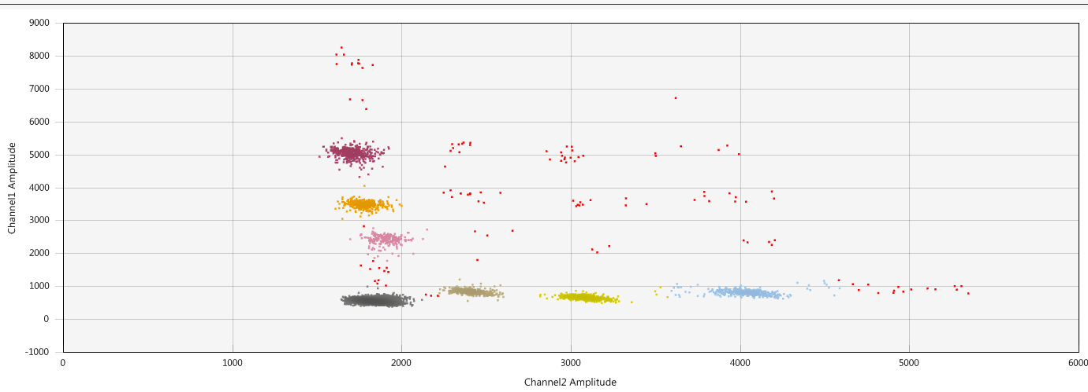  RNase P  MYC N + EIF2C1  MYC C + RNase P  EIF2C1  MYC N  MYC L  MYC C  NAGK  Empty  This compares to 7.5ng DNA where some of the double positive droplets are impossible to determine (e.g MYCN + MYCL):  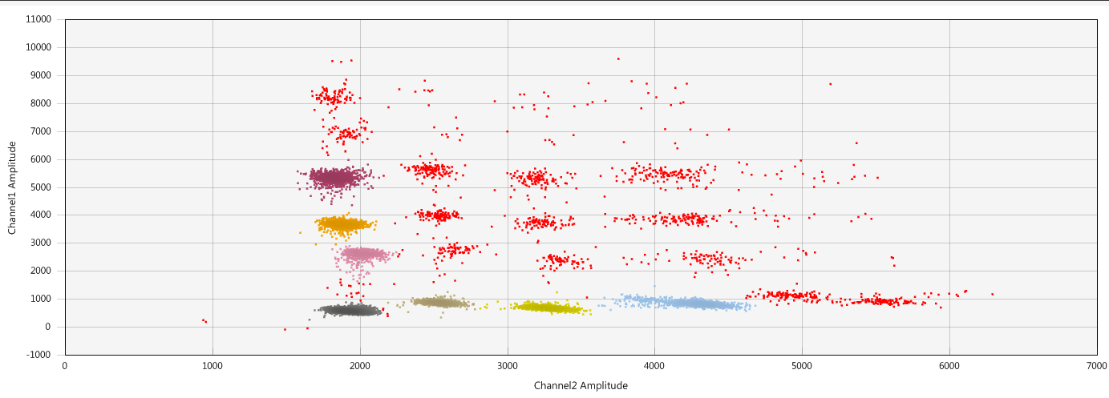  MYC N + MYC L is unknown  MYC C + MYC N?  MYC C + MYC L?  - Germline DNA from 43 patients (3 tested in duplicate) were tested where it is expected that there is no amplification in MYC genes:  None of the MYC genes were amplified in these samples (range 0.539-1.09). As opposed to the fragmented WT Promega DNA, the average MYCN ratio is similar to the other MYC genes.  - Of the 31 positive control samples, all passed QC. Of these, 27 had MYC amplification matching the result from NGS.  - When a MYC gene is highly amplified, it often appears that the other MYC genes also show slight amplification (ratio 1.2 – 2). This is due to the large number of droplets present in the true amplified cluster, as shown by testing the individual MYC assays for several samples:  - The dPCR results did not match the NGS result for four samples:  16/06998_007  Looking again at the NGS data, the copy number plot is not convincing with only a small proportion of the probes amplified which may represent amplification of only part of the gene or a false positive. This sample probably should not have been called as amplified based on this result.  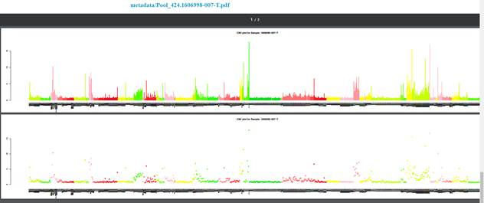  MYC N (all pink region)  17/09815_108  The copy number plot for MYC C also shows amplification of the neighbouring control region (grey region to the right of MYCC) so perhaps is amplification of the chromosomal region. In any case, it is a low level of amplification and probably shouldn’t have been called as amplified. This low level of amplification is detected in dPCR, with a ratio of 1.63.  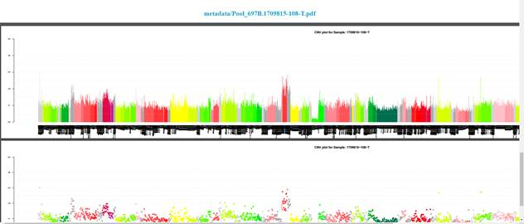  MYC C (red region)  18/01004_IE0010  MYCN does not appear to be amplified in NGS. Although there is a small increase in reads, the rest of the plot also shows variability across the genes so has probably been mis-reported. However, the dPCR results does support evidence of slight amplification (ratio = 1.76)  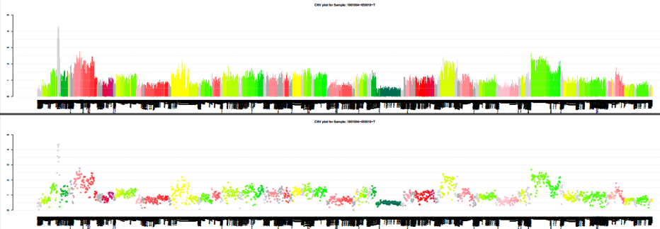  MYC N (middle pink region)  17/00442_L122  Less than half of the probes were amplified in NGS so perhaps not detected by the dPCR assay (which is in intron 2/exon 3) or the NGS is a false-positive result.  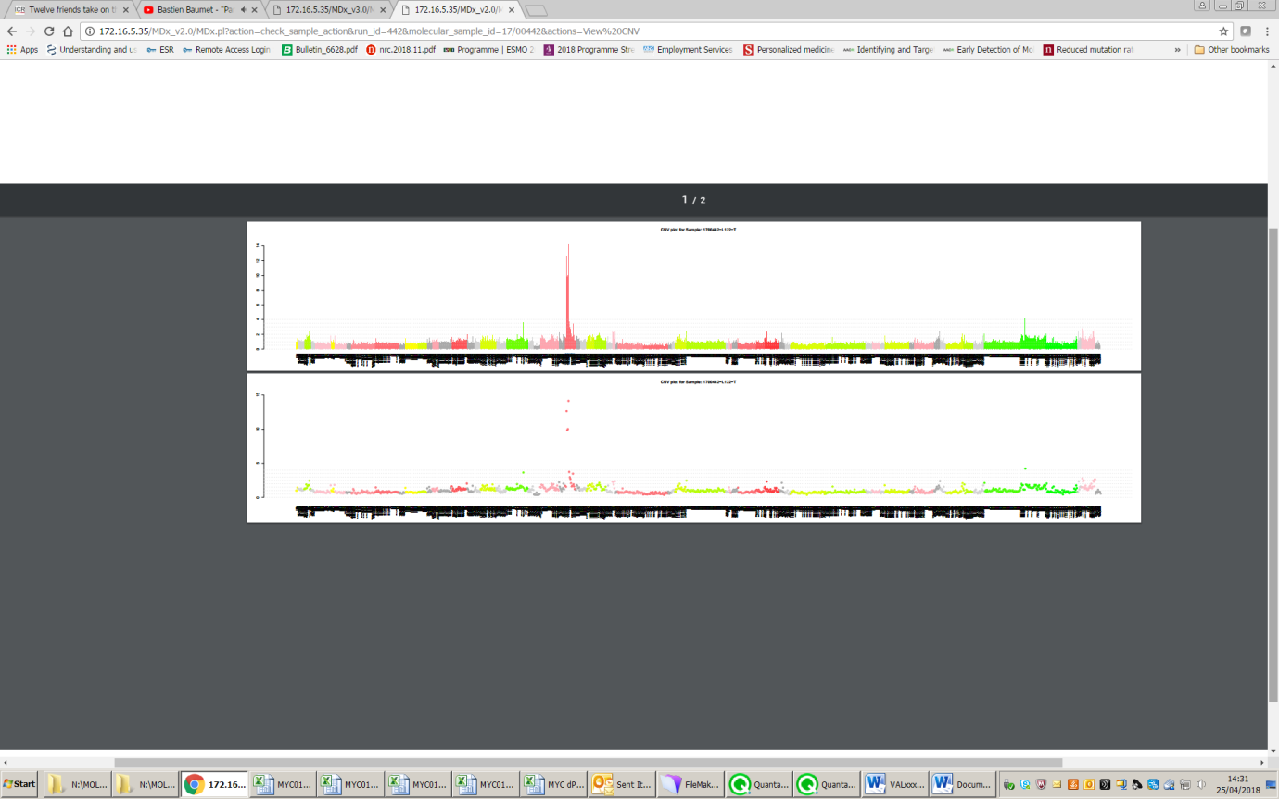  MYC N (whole red region)  - An additional 10 samples were thought to show slight MYC C amplification (called as gain) in NGS. Six of these samples would have been called as amplified by dPCR (ratio >2), with the other four showing potential amplification (ratio >1.5). This shows promise for potentially lowering the ratio threshold to >1.5.  Interestingly, 16/08973 S073 sample shows MYC L amplification (ratio = 2.75) in addition to MYC C amplification (MYC L was not on the NGS panel that was used to test this sample). The amplification was confirmed by testing the individual MYC L assay (ratio = 2.77).  Comparison of tumour and cfDNA samples  Where a plasma sample had also been collected, we could test the circulating free (cf) DNA for MYC amplification:  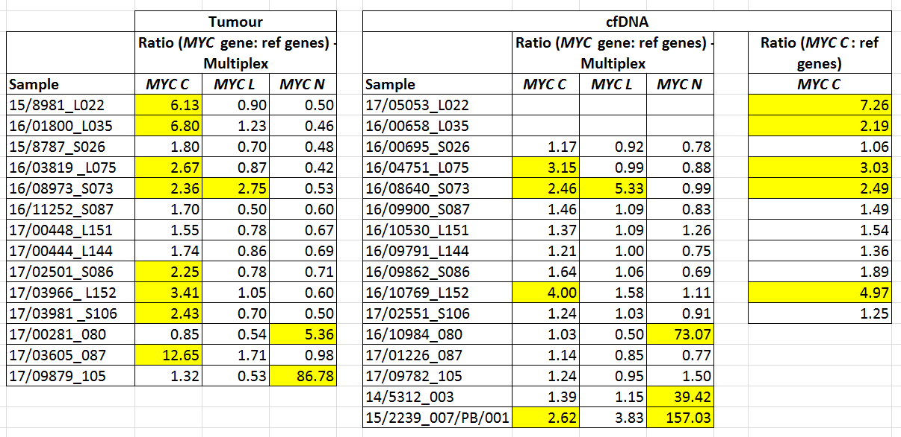  Of the 14 samples with tumour and cfDNA:  - Ten tumour samples showing clear amplification (ratio >2):  - Six showed amplification (ratio >2) in the cfDNA.  - One ctDNA samples showed possible amplification (ratio >1.5) - sample S086 ratio = 1.64.  - Three ctDNA samples did not show amplification  - For sample S106, there was a lower level of amplification in the tissue: Tissue ratio = 2.43; ctDNA ratio = 1.24  - For sample 087, the tissue had a high MYC C amplification (ratio = 12.65) but no amplification in ctDNA (ratio = 1.14). On further investigation, the tissue sample was taken in June 2012 and the plasma sample in Feb 2017. A further tissue sample was taken in Jan 2017 and NGS results showed the MYC amplification was lost. Our dPCR results confirm this.  - For sample 105, the tissue sample had a very high MYC N amplification (ratio = 87) but only slight amplification in the ctDNA (ratio = 1.5). The tissue was taken in May 2015 with the plasma taken in Sept 2017. This time difference is a likely cause for the discrepancy.  - Four tumour samples showed possible amplification (ratio 1.5 - 2)  - The ctDNA samples showed a slightly elevated ratio but would not be called as amplified (ratio 1.17 -1.46)  Copy number changes (and mutation detection) in cfDNA and tissue DNA are not always comparable for which there are several possible explanations. Firstly, cfDNA may also contain genomic DNA which may ‘dilute’ the circulating tumour DNA to an extent where copy number changes can no longer be detected. Secondly, the amount of cfDNA released into the bloodstream may be negligible as it is dependent on several factors including the tumour location and size. Thirdly, copy number changes may be present in the cfDNA that were not detected in the tumour sample – either the tissue sampled was not representative of the whole tumour or perhaps a metastatic tumour is also present that has yet to be detected/diagnosed. And finally, as we have seen here, the time between sampling of the tissue and plasma is also crucial when comparing samples.
   | Ratio (MYC gene: ref genes)
  Sample | MYC C | MYC L | MYC N
  Frag. WT Promega DNA | 0.933 | 0.815 | 0.486
  Frag. WT Promega DNA | 0.948 | 0.875 | 0.557
  Frag. WT Promega DNA | 1.00 | 0.94 | 0.39
  Frag. WT Promega DNA | 1.07 | 0.98 | 0.40
  Frag. WT Promega DNA | 1.01 | 0.82 | 0.42
  Frag. WT Promega DNA | 1.04 | 0.94 | 0.47
  Frag. WT Promega DNA | 0.93 | 0.88 | 0.43
  Frag. WT Promega DNA | 1.00 | 0.85 | 0.68
  Frag. WT Promega DNA | 1.00 | 0.83 | 0.65
  Frag. WT Promega DNA | 0.93 | 0.93 | 0.70
  Frag. WT Promega DNA | 0.88 | 0.89 | 0.63
  Average: | 0.98 | 0.89 | 0.53
   | Ratio (MYC gene: ref genes)
  Sample | MYC C | MYC L | MYC N
  17/01540_L171 | 0.873 | 0.865 | 0.665
  17/01540_L171 | 0.86 | 0.92 | 0.75
  17/00724_L165 | 0.737 | 0.872 | 0.843
  17/00724_L165 | 0.751 | 0.786 | 0.703
  15/2861_L034 | 0.625 | 0.9 | 0.918
  15/2861_L034 | 0.60 | 0.79 | 0.94
  16/09790_L143 | 0.76 | 0.841 | 0.606
  17/11215_L186 | 1.08 | 0.908 | 0.776
  17/00937_L169 | 0.707 | 0.734 | 0.719
  17/00991_L170 | 0.687 | 0.605 | 0.571
  17/02527_S105 | 0.759 | 0.832 | 0.786
  17/02552_S106 | 0.848 | 0.828 | 0.796
  17/02887_S107 | 0.849 | 0.807 | 0.933
  17/00768_L166 | 0.918 | 0.921 | 0.825
  17/00838_L168 | 0.871 | 0.917 | 0.862
  16/09863_S086 | 0.939 | 1.03 | 0.869
  16/11080_S088 | 0.761 | 0.729 | 0.61
  16/11334_S097 | 0.896 | 0.881 | 0.825
  17/02102_L155 | 0.876 | 0.868 | 0.868
  17/01539_L167 | 0.892 | 0.869 | 0.796
  15/1954_S013 | 0.64 | 0.756 | 0.981
  16/03553_S041 | 0.877 | 0.841 | 0.803
  16/08395_S072 | 0.83 | 0.784 | 0.774
  16/10529_S092 | 0.85 | 0.994 | 0.834
  16/10365_S093 | 0.906 | 0.906 | 0.877
  16/11534_S094 | 0.808 | 0.84 | 0.801
  17/01558_S098 | 0.872 | 0.923 | 0.798
  17/01495_S102 | 0.785 | 0.878 | 0.785
  16/07180_L116 | 0.67 | 0.71 | 0.77
  17/13673_L194 | 0.67 | 0.75 | 0.76
  18/00417_S115 | 0.61 | 0.81 | 0.87
  18/01132_S116 | 0.71 | 0.78 | 0.72
  18/00543_L195 | 0.79 | 0.82 | 1.09
  17/12224_S114 | 0.58 | 0.66 | 0.62
  17/08617_L184 | 0.69 | 0.73 | 0.85
  17/11479_L187 | 0.69 | 0.80 | 0.54
  17/12582_L191 | 0.67 | 0.72 | 0.73
  17/12810_L192 | 0.60 | 0.86 | 0.69
  15/9884_S036 | 0.58 | 0.67 | 0.55
  16/06485_L104 | 0.62 | 0.66 | 0.70
  16/07004_L111 | 0.62 | 0.85 | 0.73
  16/09031_L130 | 0.80 | 0.85 | 0.60
  16/11387_L161 | 0.78 | 0.82 | 0.67
  17/08523_S113 | 0.58 | 0.68 | 0.68
  17/11480_L182 | 0.68 | 0.83 | 0.76
  16/03328_S027 | 0.62 | 0.66 | 0.88
  Average: | 0.757 | 0.815 | 0.772
  Min: | 0.575 | 0.605 | 0.539
  Max: | 1.08 | 1.03 | 1.09
   | Ratio (MYC gene: ref genes) |  |  | Gene amplified by NGS
  Sample | MYC C | MYC L | MYC N | Gene amplified by NGS
  16/01104_NMB866 | 0.91 | 1.06 | 18.17 | MYCN
  16/09532_11-1015 | 0.70 | 0.45 | 12.83 | MYCN
  17/09561_118 | 1.29 | 0.99 | 87.80 | MYCN
  18/00331_CLBBAR | 1.65 | 1.15 | 45.07 | MYCN
  18/00334_CLBRE | 1.52 | 0.98 | 48.58 | MYCN
  18/00335_IMR32 | 1.22 | 0.64 | 41.08 | MYCN
  18/00336_CLBMA | 1.52 | 0.76 | 76.81 | MYCN
  18/00337_SJNB8 | 1.52 | 1.10 | 93.24 | MYCN
  18/00339_CLBBRAY | 1.55 | 0.55 | 49.50 | MYCN
  18/00340_BABEY | 1.78 | 0.82 | 65.36 | MYCN
  18/00343_SKND2 | 1.38 | 1.11 | 62.63 | MYCN
  18/00344_CLBBE | 1.57 | 0.89 | 112.78 | MYCN
  18/00346_KCNR | 1.92 | 0.62 | 118.88 | MYCN
  18/00350_106C | 1.16 | 1.28 | 23.03 | MYCN
  18/00700_22448 | 41.74 | 1.70 | 0.49 | MYCC
  18/01003_BE0118DL | 1.35 | 0.67 | 33.93 | MYCN
  17/09878_116 | 1.24 | 0.71 | 78.12 | MYCN
  18/00342_TR14 | 1.39 | 0.72 | 191.60 | MYCN
  18/00338_N206 | 1.56 | 2.02 | 172.19 | MYCN
  16/06890_G2230 | 0.59 | 1.68 | 38.04 | MYCN
  16/10795_11/1017 | 0.55 | 1.32 | 3.12 | MYCN
  17/04679_11/989 | 0.97 | 0.69 | 138.45 | MYCN
  16/06998_007 | 0.49 | 0.66 | 1.26 | MYCN
  18/01004_IE0010 | 1.12 | 0.55 | 1.76 | MYCN
  17/09815_108 | 1.63 | 0.74 | 0.40 | MYCC
  17/00442_L122 | 1.19 | 0.81 | 0.60 | MYCC
  17/00281_080 | 0.85 | 0.54 | 5.36 | MYCN
  17/03605_087 | 12.65 | 1.71 | 0.98 | MYCC
  17/09879_105 | 1.32 | 0.53 | 86.78 | MYCN
  15/8981_L022 | 6.13 | 0.90 | 0.50 | MYCC
  16/01800_L035 | 6.80 | 1.23 | 0.46 | MYCC
   | Ratio (MYC gene: ref genes) - each MYC gene run separately
  Sample | MYC C | MYC L | MYC N
  16/01104 NMB866T |  |  | 20.17
  15/8981_L022 | 5.64
  16/09532_11-1015 |  |  | 15.21
  17/09879_105 | 1.11 |  | 91.08
  17/09561_118 | 0.87 | 1.08 | 98.77
  17/09878_116 | 1.07 |  | 88.38
  18/00331_CLBBAR | 0.99 | 1.13 | 48.28
  18/00334_CLBRE | 0.73 | 0.90 | 52.74
  18/00335_IMR32 | 0.96 | 0.59 | 42.86
  18/00336_CLBMA | 0.89 | 0.56 | 82.39
  18/00337_SJNB8 | 0.66 | 0.81 | 95.77
  18/00339_CLBBRAY | 0.92 |  | 59.48
  18/00340_BABEY | 1.26 | 0.70 | 69.17
  18/00343_SKND2 | 0.97 | 0.90 | 72.39
  18/00344_CLBBE | 0.72 | 0.79 | 132.66
  18/00346_KCNR | 1.07 | 0.59 | 126.44
  18/00350_106C | 0.76 | 1.22 | 23.81
  18/00700_22448 | 37.45 | 1.10
  18/01003_BE0118DL | 1.04 |  | 38.73
  16/01800_L035 | 6.26
   | Ratio (MYC gene: ref genes) |  |  | Gene amplified by NGS
  Sample | MYC C | MYC L | MYC N | Gene amplified by NGS
  16/06998_007 | 0.49 | 0.66 | 1.26 | MYCN
  17/09815_108 | 1.63 | 0.74 | 0.40 | MYCC
  18/01004_IE0010 | 1.12 | 0.55 | 1.76 | MYCN
  17/00442_L122 | 1.19 | 0.81 | 0.60 | MYCC
   | Ratio (MYC gene: ref genes)
  Sample | MYC C | MYC L | MYC N
  15/8787_S026 | 1.80 | 0.70 | 0.48
  16/03819 _L075 | 2.67 | 0.87 | 0.42
  16/08973_S073 | 2.36 | 2.75 | 0.53
  16/11252_S087 | 1.70 | 0.50 | 0.60
  17/00448_L151 | 1.55 | 0.78 | 0.67
  17/00444_L144 | 1.74 | 0.86 | 0.69
  17/02501_S086 | 2.25 | 0.78 | 0.71
  17/03966_ L152 | 3.41 | 1.05 | 0.60
  17/03981 _S106 | 2.43 | 0.70 | 0.50
  16/05707_L089 | 2.79 | 0.76 | 0.69
Equipment Cross check/ Comparability | establishing the comparability of results across testing equipment and analysers.  dPCR replicates the NGS amplification results for 27/31 samples. However, on subsequent review of the NGS data for the four non-concordant results, MYC amplification probably should not have been reported as it was not convincing data.
Interpretation | Summarise the interpretation of experimental results (e.g. estimated level of accuracy with confidence limits)  We are satisfied that dPCR is a reliable and accurate method to determine MYC copy number independent of NGS.
Uncertainty of Measurement | determine for each of the critical measurement steps in the procedures (pipette volume and thermocycler annealing temperature), and the influence of the determined UoMs on Results  Uncertainty of measurement has previously been determined for dPCR and acceptable variability of pipette volumes and thermocycler annealing temperatures do not affect the results.
Outcome / limitations | - State whether the results fulfil the validation requirements listed in 1.2  - List any specific derived limitations to reproduce the outcome (e.g. controls and how they should be used)  The results fulfil the validation requirements. The current limitation is that we do not have any positive controls for MYC L so this validation will be ongoing.

4. Validation / Verification Final Conclusions

Test name | MYC amplification ddPCR assay | Reference | Internal ref.

Overall Conclusion | State explicitly if the requirements in 1.2 have been fulfilled;  Give any other relevant conclusions.  We have shown that dPCR can be used to detect amplification in MYC genes. We have validated the results for MYC C and MYC N but as yet do not have any positive control samples for MYC L but anticipate the assay to work as the others.  None of the MYC genes were amplified in 43 germline controls (range 0.539-1.09).  Of the 31 positive control samples, 27 of these had MYC amplification matching the result from NGS.  The dPCR results did not match the NGS result for four samples but on reanalysing the NGS data, it appears that these should not have been reported as amplified.  We will call a MYC gene as amplified if the ratio (compared to control genes) is >2. There is the potential for this to be lowered in the future if we are confident that the gene is amplified (e.g. comparing results to another technique which called amplification).  We have also shown that MYC amplification can be detected in cfDNA.
Parameters met | Sensitivity: Specificity: Accuracy: etc  The dPCR results did not match the NGS result for four samples but on reanalysing the NGS data, it appears that these should not have been reported as amplified.  Excluding these 4 samples, for the 27 tumour samples showing amplification and the 43 germline controls, this shows:  - Sensitivity = 100 % (95% CI: 87.23% - 100%)  - Specificity = 100 % (95% CI: 91.78% - 100%)  - Accuracy = 100 % (95% CI: 94.87% - 100%)
Estimates of accuracy and measures of uncertainty | Give experimentally-derived values for the relevant metrics.  Comment on the potential influence of the uncertainty on the reliability of the result.
Limitations and/or predictable interferences | List all limitations and control measures required to maintain the on-going test performance  One limitation is that we do not have any positive control samples for MYC L amplification. Therefore, we await the first positive sample to ensure the assay will detect amplification. However, we have detected MYC L amplification in a tumour sample (S073) which was detected by dPCR in both the multiplex and individual MYC L assay. We don’t have this confirmed by an independent diagnostic method.  As for other dPCR assays, we will monitor the ongoing performance by including positive and negative controls on each plate run.
Internal QC | Detail internal quality control measures to be implemented, addressing in particular the limitations and interferences identified.  As for other dPCR assays, we will monitor the ongoing performance by including positive and negative controls on each plate run.  We will also use QC thresholds currently in use – namely that >10,000 total droplets must be present. In addition, if no amplification is detected >300 droplets for the reference genes will be required to pass QC.
External QA | Details of external quality assurance measures  No external QA.

Authorization | Name | Signature | Date
Investigating scientist | Hannah Bye | Hannah Bye | 02/05/2018
Senior Scientist (Authorization)

Appendix A: Types of test. (Refer to main paper for full descriptions of test types)
NB. In addition to the parameters detailed below appropriate robustness testing should be carried out for all types of test.

 | Description | Examples | Sensitivityª | Specificity^{b} | Accuracy^{c} | Trueness | Precision^{d} | Limits of detection | Probability^{e}
A | Quantitative tests.  The result can have any value between two limits (including decimals). | Determination of methylation load (%); characterization of a mosaic mutation; heteroplasmy of mitochondrial variants. | v |  |  | ++ | ++ | ++
B | Categorical tests where the quantitative signal is placed into an ordinal series to give the final result. | Sizing a PCR product; determination of triplet repeat size (FRAXA, Huntington disease, etc.) |  |  | + | ++ | ++ | ++ | +
C | Categorical tests where the quantitative signal is placed into one of a limited series of predefined categories to give the final result. | Determination of copy number using PCR or MLPA.: exon deletion / duplication in BRCA1; PMP22 gene dosage in CMT and HNPP; |  |  | + | To establish correction factors and/or cut-offs |  |  | ++
D | Qualitative tests where the true quantitative signal can have one of many possible values, but the required result can only have one of two possible values. | Mutation scanning for unknown mutations e.g. by sequencing or high resolution melt. | ++ | ++ | + | To establish correction factors and/or cut-offs |  | ++^{f}
E | Qualitative [binary] tests where the true quantitative signal can only have one of two possible values | Genotyping for a specific mutation e.g. CFTR Phe508del in cystic fibrosis or HFE Cys282Tyr in hemochromatosis. | ++ | ++ | + | To establish correction factors and/or cut-offs |  | ++ ^{f} | +
Legend Notes
 | Metric used for implementation validation | a. | Sensitivity = True Positive / (True Positive + False Negative)
 | Metric used for implementation or ongoing validation | b. | Specificity = True Negative / (True Negative + False Positive)
 | Metric used for ongoing validation | c. | Accuracy = True Result / (True Result + False Result)
++ | Recommended parameter | d. | Precision should be measured in terms of repeatability and intermediate precision (as well as reproducibility for inter-laboratory validations)
+ | Applicable parameter (less used) | e. | The term ‘probability’ is used to describe situations where a probability that the result is correct can be assigned – primarily in ongoing validation (e.g. competitive hypothesis testing)
 |  | f. | Should be used in tests where genotyping of low level variations is required for example mitochondrial DNA

Appendix B: Administrative checklist

 |  | Date | Initials
 | Validation completed and approved
 | Complete SOP
 | Order reagents
 | Health and safety aspects (personal, reagents)
 | Equipment (electrical testing, maintenance)
 | Subscribe to EQA
 | Update request forms
 | Update website and any directory listings
 | Billing procedure
 | Training
 | LIMS functionality
 | Worksheets
 | Inform clients
 | Report template

(ISO 9000:2005 3.8.4, 3.8.5)
Delete as appropriate
Delete as appropriate

